**Name:** Khot Aniket Tanaji  
**Batch & Roll:** A3-63

**Experiment No.1**

**Title:** Installation of Android Studio and Introduction to Basic Components.

**Android Studio system requirements:**

* 64-bit OS and Windows 8/10/11.
* 8GB RAM or more.
* Enable PC’s Virtualization.
* Disable Windows Hypervisor.
* Intel Haxm Accelerator.

**Version:** 2021.2.1 (Chipmunk) / 9 May 2022

**XML:** activity_main.xml

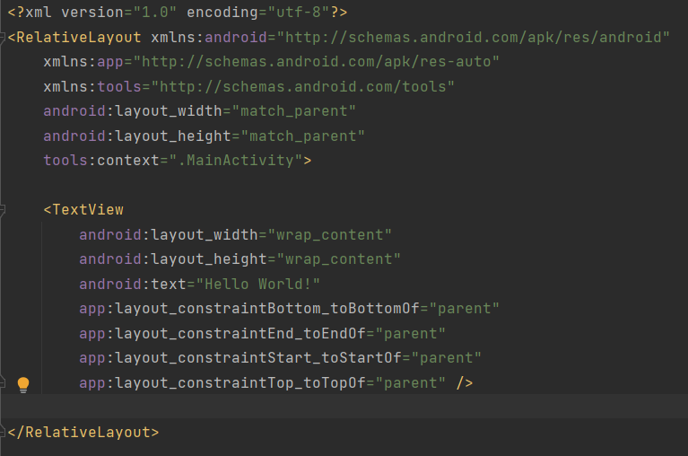

XML is used to implement UI-related data, and it's a lightweight markup language that doesn't make layout heavy.

**JAVA:** MainActivity.java

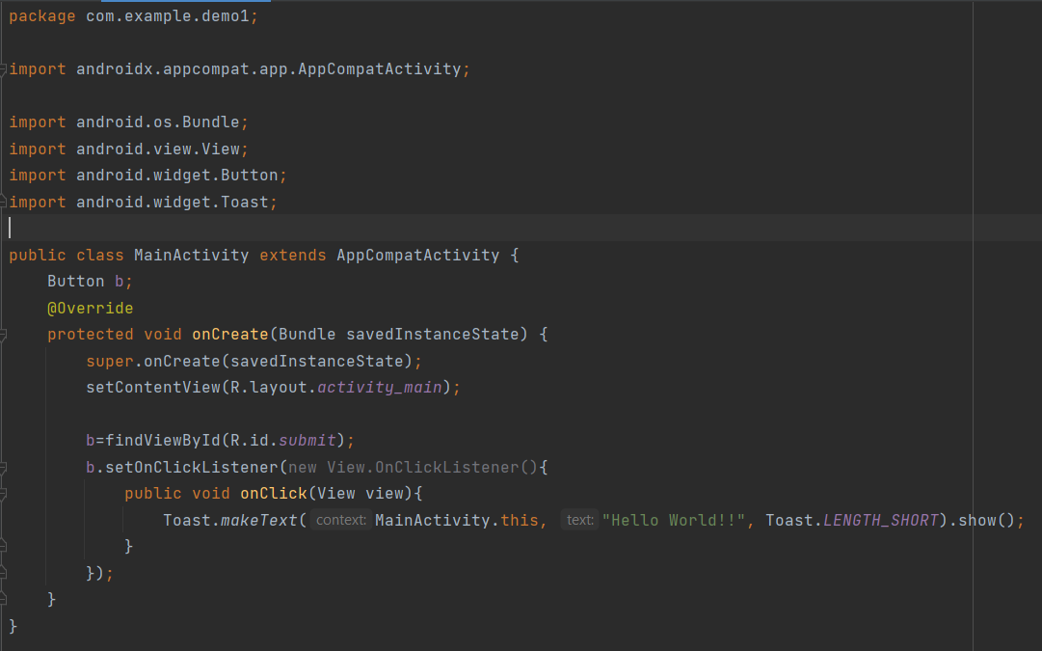

The Java folder contains the Java source code files. These files are used as a controller for controlled UI (Layout file). It gets the data from the Layout file and after processing that data output will be shown in the UI layout. It works on the backend of an Android application.

**Activity:**

An Activity is an application component that provides a screen with which users can interact in order to do something.

**SDK:**

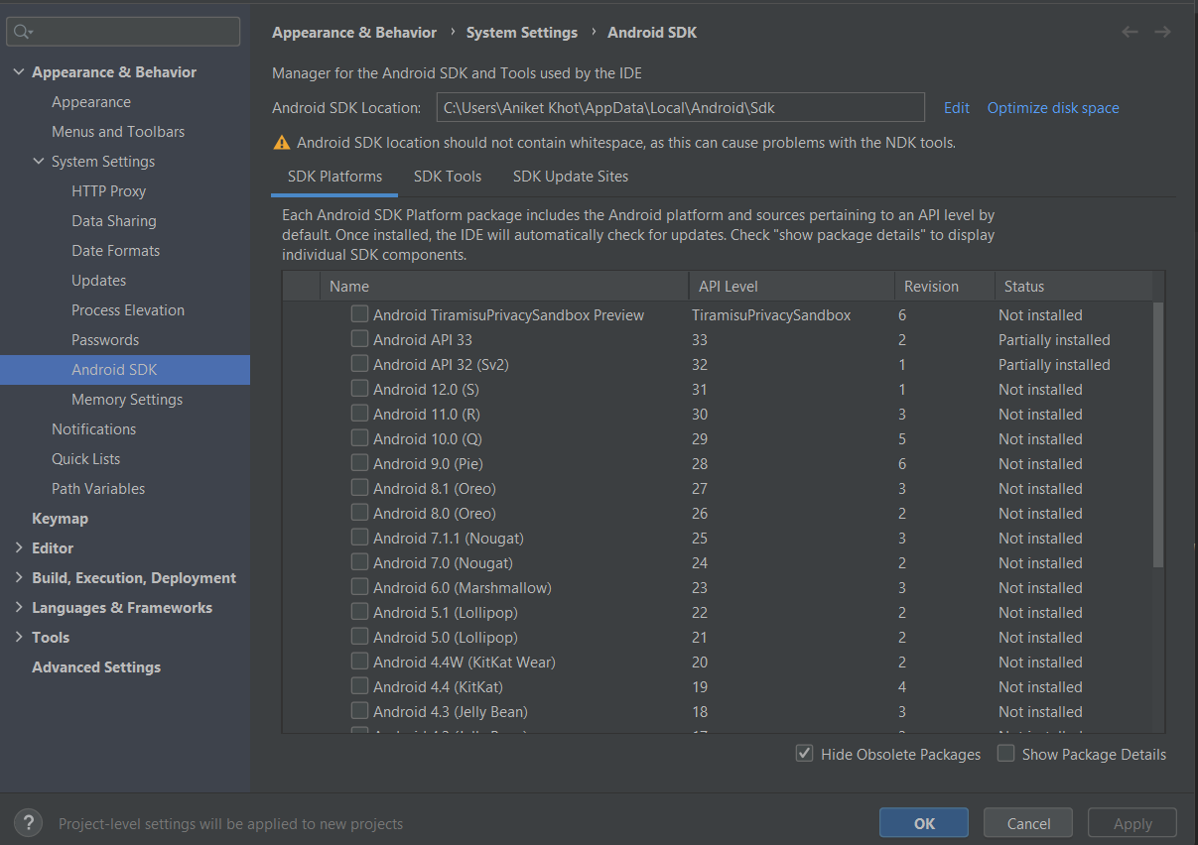The Android SDK is a software development kit that includes a comprehensive set of development tools like  
Libraries  
Debugger  
Emulator  
API  
Sample Source Code

**AVD:  
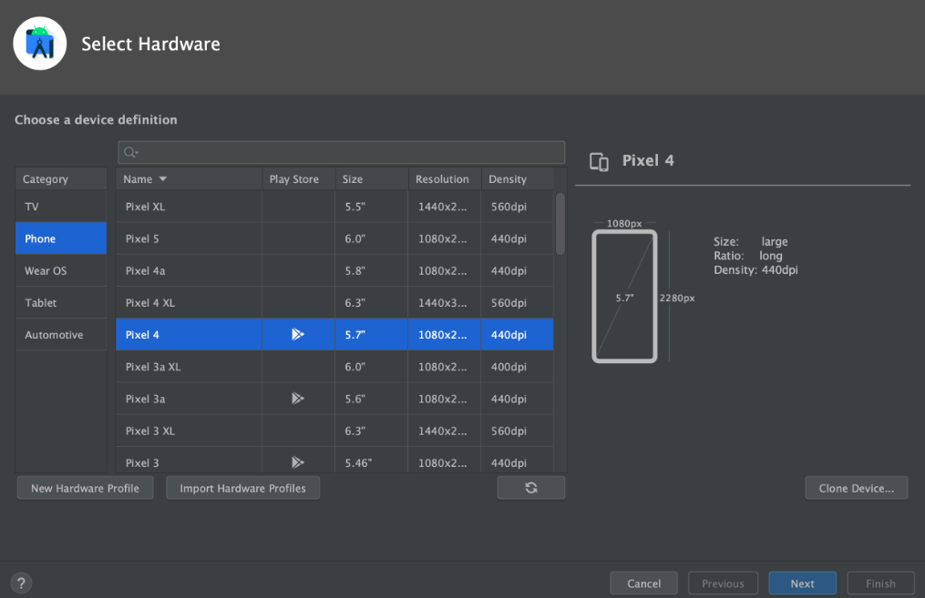**

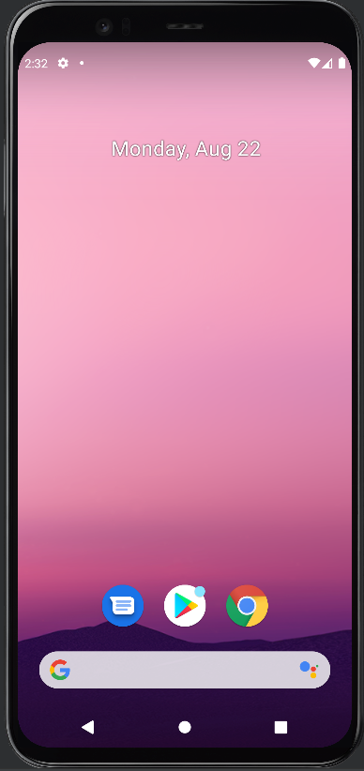An Android Virtual Device (AVD) is a configuration that defines the characteristics of an Android phone, tablet, Wear OS, Android TV, or Automotive OS device that you want to simulate in the Android Emulator.

**Gradle:**An advanced build toolkit, to automate and manage the build process, while allowing you to define flexible custom build configurations. It is the tool is used to automate the creation of applications.

**Project Directory Structure:  
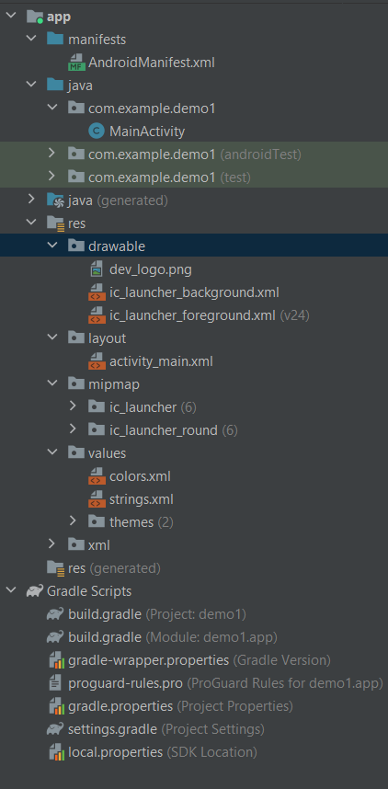**Manifest: This file contains the permissions that are required to run our file.

Java: This files contains all the logic and background code for our application.

Res:  
drawable: Contains images that are required for the application.  
layout: Contains all the XML files of our applications.  
mipmap: Contains all types of icons of required for our application.  
values: Contains the color and string required for application.

Gradle Scripts: All the gradle build files required to run our application.

**Run:**

After clicking the run button the emulator will open and the application is launched.

